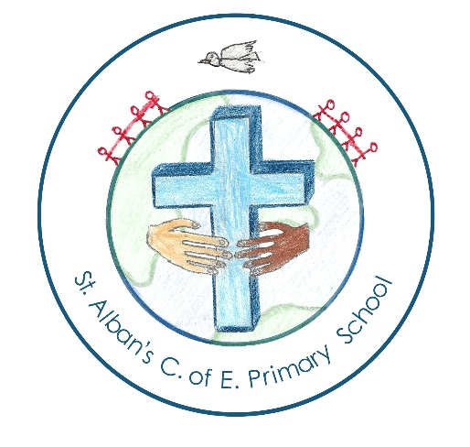

wednesday 5th October

St. Alban’s Newsletter

On Wednesday morning the school photographer will be taking individual and sibling photos. If your child attends nursery in the afternoon, then the photographer will take their photos at 8:30am in the hall. .
Parent meetings are a great opportunity for you to meet your child’s class teacher and find out about class routines and expectations. Parent meetings will take place in your child’s classroom and will start at 2:30pm (year2 starts at 2:00pm) and finish for 3:00pm pick up time.
3rd October – Year 6
4th October – Year 5
5th October – Year 4
6th October – Year 3
10th October- Year 2
7th October – Year 1

ATTENDaNCE CHAMPIONS

Winning class: Year 1 | Year 6
100%
Well done, every day in school matters.
2nd | Foundation 2 and Year 4
99.3%
3rd | Years 1 & 3
98.7%
4th | Year 2
98%
5th | Year 5
95.3%

School dinner update
Thank you for your continued support during the transition to our new school dinner provider, Dolce. We have received very good reports from children and staff. Please remember to order your meals online at www.live-kitchen.co.uk/cashless. All meals must be ordered by 9:00am so that the kitchen have time to prepare.
Houses Points
Carmel | 163
Jericho | 121
Jordan | 142
Sinai | 164

Notices
Photo Permission Slips
Before the summer holidays we sent out a letter asking for permission to put photos of your children on the school website, school displays and other publications. We are still waiting for many parents to reply. If you have misplaced the letter then please ask for a copy from the school office.
Flu Vaccinations
The nurse will be administrating flu vaccinations on Wednesday 12th October to children in years 1, 2 and 3. All permission slips must be returned to school before Friday 7th October.
Harvest Festival
Our harvest celebration is at 10:00am on Friday 7th October. Parents, Carers and Grandparents are welcome to join us for the service at St Alban’s Church. If you would like to donate then please send in to school non-perishable foods, such as tins, jars or cereals. All donations will be given to Rotherham Food Bank.
Celebration Assembly
Well done to all the children who received a special mention, we are very proud of you.
FS2 | Evie and Sapphire
Year 1 | Jasmine, Riley and Kate
Year 2 | Emily and Joel
Year 3 | Jacob and Amelia
Year 4 | Harrison and Charlotte
Year 5 | Charlie and Daisy
Year 6 | At Whitby
FS1 Stars of the Week
Morning session: Alexander
Afternoon session: Christopher
www.wsap.academy

