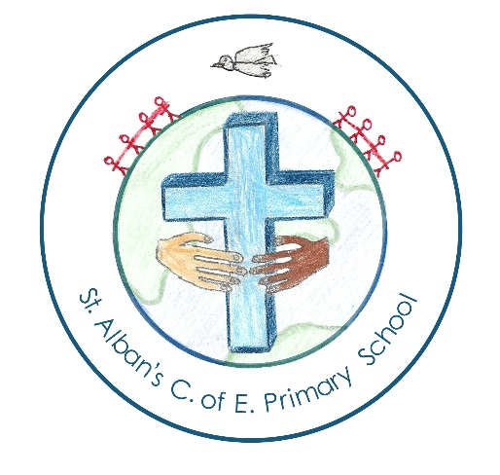

our chosen charity

St. Alban’s Newsletter

This year we have decided to donate all money raised from Christmas Concerts to Sunbeams based at Rotherham Hospice. Sunbeams support children who are recently or soon to be bereaved to help them to go through the stages of bereavement with special support, and to remember their loved one in a positive and helpful way.
Last year we £300 for Diabetes UK and the year 4 students raised £325 for WWF UK as part of their Rainforest topic.
House Leadership Projects
House Leaders have decided to improve an area of school life as they really want to make a difference. This week they have been very busy collecting pupil’s ideas and then writing action plans. If you would like to read the house action plans, copies can be found on our school website. The House Leaders are looking for people to help put their plans into action! So if you feel that you have skills to share or time to spare then please speak to Mrs Gurner if you can help.
Carmel: To improve spelling
Sinai: To improve the school library and begin a book review club.
Jordan: To improve the school environment
Jericho: To improve mathematics.
www.wsap.academy
Book Recommendation!
A few parents have asked for further support with Spelling, Punctuation and Grammar (SPAG) terminology. We use- Oxford Primary Grammar, Punctuation and Spelling Dictionary (ISBN 978-019-273421-1) in school. To further support parents we are planning to host parent workshops later in the year.
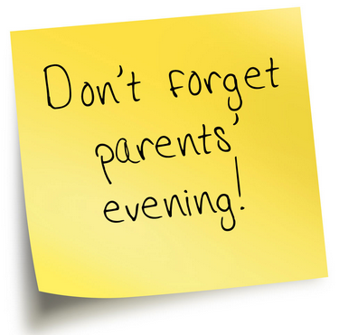
Don’t forget to book your parent interviews before we break up for half term. Reminder letters have been sent out this week. Teaching staff will hold the meetings on 1/11/16 from 3:15pm-6:30pm or during the afternoons below.
Parent Interview Afternoons (12:00-3:30)
Foundation 1 (am) | 4/11/16
Foundation 2 | 3/11/16
Year 1 | 3/11/16
Year 2 | 4/11/16
Year 3 | 2/11/16
Year 4 | 3/11/16
Year 5 | 4/11/16
Year 6 | 4/11/16

ATTENDaNCE CHAMPIONS

Winning class: Year 1 | Year 5 and Year 2
99.3%
Well done, every day in school matters.
2nd | Year 1
98.7%
3rd | Year 3 & Year 6
97.3%
4th | Years 4
97%
5th | FS2
96.7%

pta christmas card project
The PTA is working once again with Art Projects for Schools Ltd. To offer your child the opportunity to have their Christmas card design (or any other design) printed on to cards or wrapping paper for you to purchase.

The children will start work on their cards in class- you can use these designs, or if you prefer, make a new design with your child at home. Ideas can be found on printrest or on www.apfs.org.uk/resrouces.

You must place your order and pay online at www.apfsorders.co.uk using your unique reference on the order form enclosed in your card pack. The closing date to place orders and pay is Tuesday 8th November. The closing date for card designs to be handed at school is 9am on Friday 11th November. These deadlines are set by APFS and are not extendable.
The funds raised will be used for the benefit of all the school.

We will be sending out further information and card packs before the children break up for half term.

