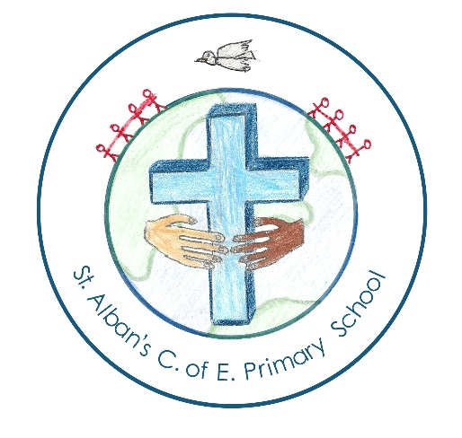

New Scheme
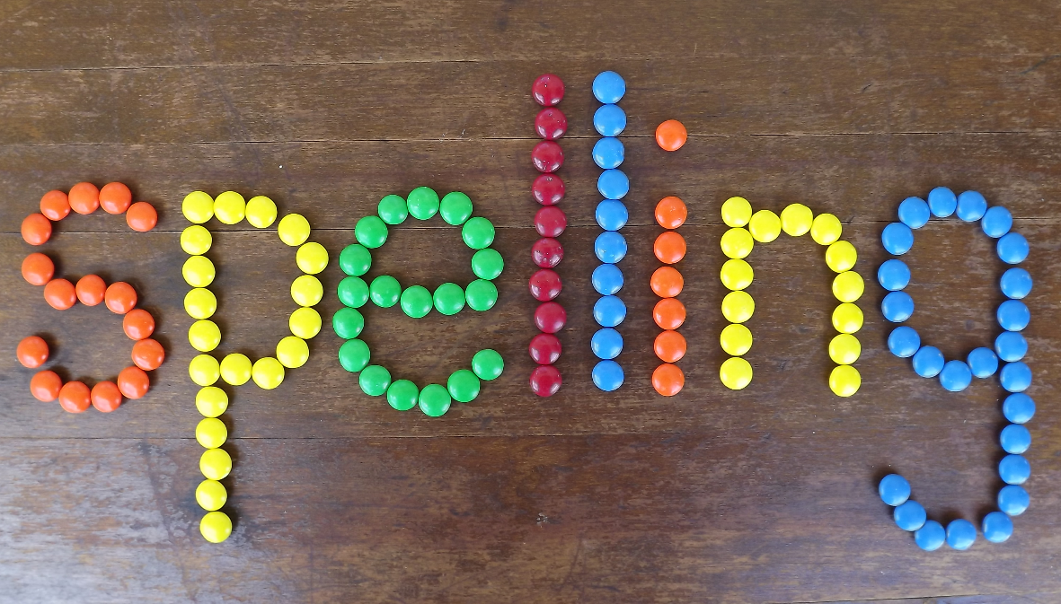

St. Alban’s Newsletter

Next half term we are launching Read Write Inc. Spelling for children in years 2 and above. The new programme will change the way that we conduct spelling tests in class. After the holidays we will invite all parents to a curriculum morning, so that you can see the new scheme in action.
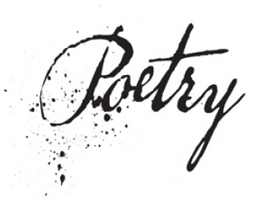
Year 2 children have been very busy writing poetry about ‘Life in the Pit’. To raise money for Sunbeams they are selling their anthologies for £1. If you would like to purchase your own copy then please ask Mrs. Teale.
Houses Points
Carmel | 533
Jericho | 526
Jordan | 461
Sinai | 539
FS1 Stars of the Week
Morning session: Frankie
Afternoon session: Daisy
www.wsap.academy

ATTENDaNCE CHAMPIONS

Winning class: Year 1 | Year 2
98%
Well done, every day in school matters.
2nd | Years 6 & 4
96.7%
3rd | Foundation 2 & year 1
96%
4th | Year 3
93.7%
5th | Year 5
90%

Gift experience
The PTA are organising a gift experience on 17th November from 7-8:30pm. The event is set to be a great evening, very kindly supported by many bespoke shops and boutiques from the area.
Tickets are £3.50 per person. This will include a drink on arrival and a variety of nibbles throughout the evening as well as entry into a Prize Draw. The PTA have sent out ticket order forms, so please look out for these in your child’s book bag.

Notices
Parents Evenings
Teaching staff will hold the parent meetings on 1/11/16 from 3:15pm-6:30pm or during the afternoons below.
Parent Interview Afternoons (12:00-3:30)
Foundation 1 (am) | 4/11/16
Foundation 2 | 3/11/16
Year 1 | 3/11/16
Year 2 | 4/11/16
Year 3 | 2/11/16
Year 4 | 3/11/16
Year 5 | 4/11/16
Year 6 | 4/11/16
School Photos
All school photos orders must be handed in to the school office by 8:45am on Monday 31st October.
Cross Country Champion
We are so proud the year 3 and 4 girls who won the Rotherham Cross Country Finals- you were fantastic. We would also like to congratulate Annaliese who came first in the whole competition- next the Olympics!
Celebration Assembly
Well done to all the children who received a special mention, we are very proud of you.
FS2 | Lillie
Year 1 | Archie, Jack and Edward
Year 2 | Blake and Amelia
Year 3 | Milo and Rosie
Year 4 | Bryn and Henry
Year 5 | Jake and Lewis
Year 6 | The whole class

