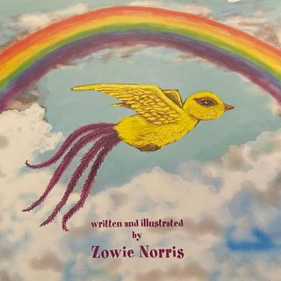

**Author Day – Friday 1st October- Zowie Norris**

Dear Parents, Carers & Children at St Alban’s Primary School,

I am excited to visit your school on Friday 1st October for an ‘Author day’, where I will share my new story ‘Barb the Bird of Hope’. I will talk to the children about my inspiration for the story and my journey to becoming a new Rotherham author and illustrator.

Barb the Bird of Hope

This story is based around the theme of having hope. Barb is an unusual bird who lives in a laburnum tree in Bretton Park. She is a symbol of hope for the other birds in the park and provides hope for some of the daily visitors too. Things take a turn for the worst – a pandemic changes everything and a terrible storm destroys the park and Barb’s tree. Will things get better? Will hope be restored?

Available online at

***Authorhouse.co.uk, Amazon.co.uk, Waterstones.co.uk, Goodreads.com, plus others***

If you would like your child to purchase a signed copy on the day at a special price of £8 with a bookmark gift, please complete and return the slip below.

With much hope and happiness

Zowie Norris

Name of Pupil:________ Year group_________

I would like to purchase a signed copy of ‘Barb the Bird of Hope’ by Zowie Norris and enclose £8 Please sign the book to : ______________

I give consent to photos of my child on the school website and author social media pages.

Signature of Parent: ___________