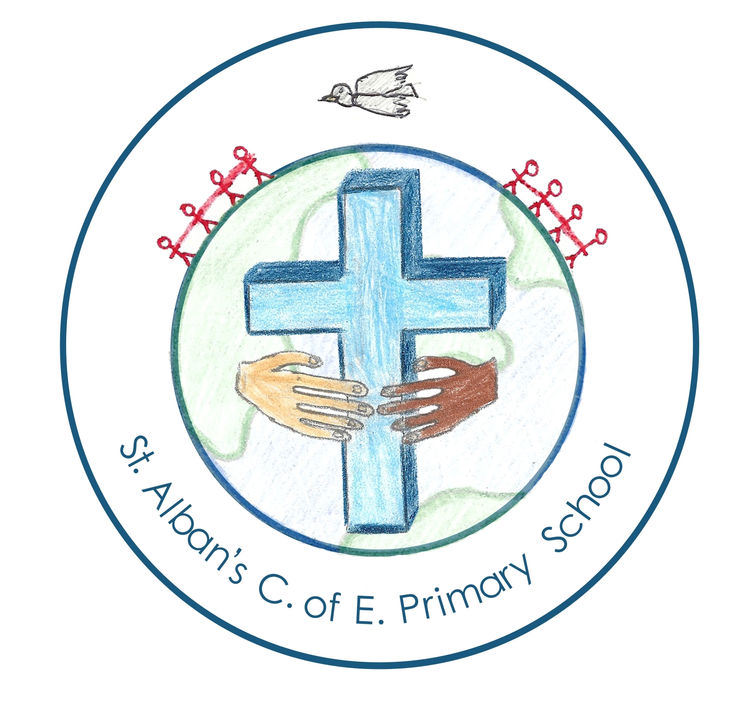 | Year 1 | Year 2 | Year 3 | Year 4 | Year 5 | Year 6
 | KS1 Working scientifically |  | LKS2 Working Scientifically |  | UKS2 Working Scientifically
Biology | Types of Animals  Parts of animals  (including humans) | Feeding and Exercise  (including humans)  Living Things 2 | Movement and Feeding (including humans) | Human Nutrition | Life Cycles  (including changes in humans) | Our Bodies (Circulation, healthy living and transport of water and nutrients)  Evolution and Inheritance
 |  | Habitats  Living Things (Things that all living things have in common) |  | Dangers to Living Things  Grouping Living Things |  | Classifying living things
 | Plants (identifying and structure) | Growing Plants | Parts of a Plant  (structure and function)  What plants need
Chemistry | Comparing Materials  Identifying Materials | Changing Shape  Uses of Materials |  | Changes of State | Separating  mixtures  Types of change  Materials
 |  |  | Rocks and Soils
Physics | Changing Seasons |  |  |  | Earth and Space
 |  |  |  | Electricity |  | Changing circuits
 |  |  | Light and Shadows |  | Forces | Light and sound
 |  |  | Magnets and Forces
 |  |  |  | Sound

