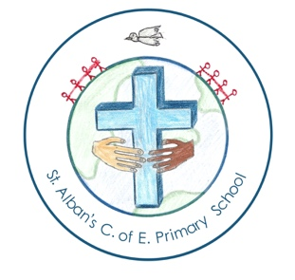 | St Alban’s CE Primary School  Executive Headteacher: Mrs Alison Adair  Head of school: Mrs Amy Gurner/ Mrs Hannah Lambert  Morthen Road, Rotherham, S66 1EU. Tel: 01709 542878.  Email: stalbans@sap.dsat.education  “Educating for life in all its fullness.” | 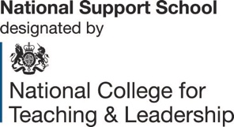

15th November 2019

Dear Parents,

Welcome to Miss Rosie May Grace Gurner, pictured below with Mrs Gurner, who visited school this afternoon! Mum and baby doing well! Mrs Gurner is returning from maternity leave in February, so enjoying special moments with Rosie, Monty and Annie until then.

Christmas celebrations:

At the beginning of term, you will have been sent the dates list for the year, which includes details of Christmas events at school. A list of the key events are provided below as a reminder. Please note that Christmas plays and Carol Concerts for all pupils are being held this year in the school hall, including the Junior concert.
In addition, St Albans Church have also invited parents and children to a school Christmas service nearer the end of term, which will take place at 3.30pm. Everyone is welcome to attend.

Key dates:
FS1 concert 10th December 9.15
Junior Carol concert in school 10th December 1.30pm and 5pm.
FS2, Y1, Y2 Carol concert 12th December 9.30 a.m. and 1.30 pm.
Christmas dinner 17th December
School closes 19th December 1.30 p.m.

Please be in touch if you have any questions,

Alison Adair
Executive Headteacher

