Year 1 Homework
Next half term our topic will be ‘Paws, claws and whiskers’. We will be finding out about the variety of common animals including fish, amphibians, reptiles, birds and mammals.
Animals
I would like you to research an animal that you are interested in finding out about. This can be any animal, lions, sharks, snakes, bears, frogs, crocodile etc. the choice is totally yours.
Think about what the animal looks like, where they live, what they eat and what they can do.
You can present your work in any way you would like to:
- Poster
- Information guide
- Booklet
- Create a painting/picture, model, etc of your animal.
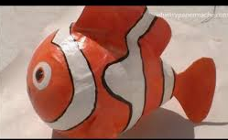
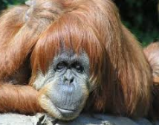
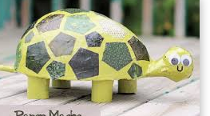
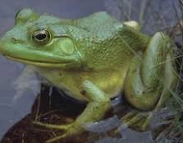
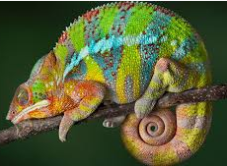
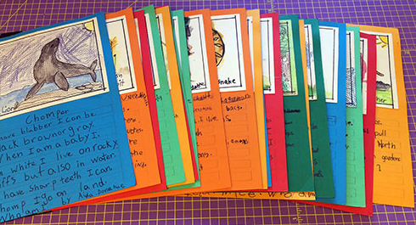
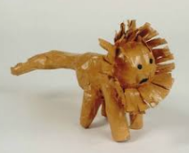
Be creative and have fun!

