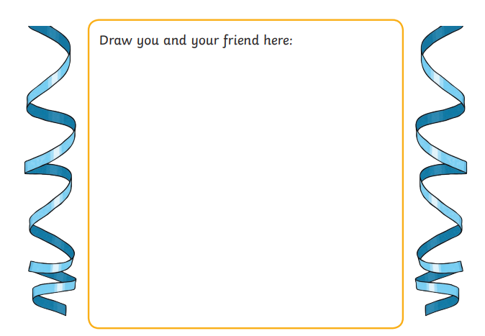
My Friend
__________________________________________________________________________________________ __________________________________________________________________________________________________________________________________________________________________________________________________________________

